**Air, Oxygen and Combustion**

**The Atmosphere**

The atmosphere is made up of air, a mixture of colourless, odorless gases which is felt as wind.  
There are various gases in the atmosphere a listed below with their percentage composition;

(i) Nitrogen - 78%  
(ii) Oxygen - 21%  
(iii) Carbon (IV) Oxide - 0.03%  
(iv) Noble gases - 1%  
(v) Water Vapour - varies by region

There are different experiments that could be used to demonstrate presence and composition of the above gases in air  
Some of them include;

**Finding the composition of air supporting combustion using a candle stick**

**Procedure**  
Measure the length of an empty gas jar M1. Place a candle stick on a Petri dish. Float it on water in basin/trough. Cover it with the gas jar. Mark the level of the water in the gas jar M2. Remove the gas jar. Light the candle sick. Carefully cover it with the gas jar. Observe for two minutes. Mark the new level of the water M3. Set up of apparatus

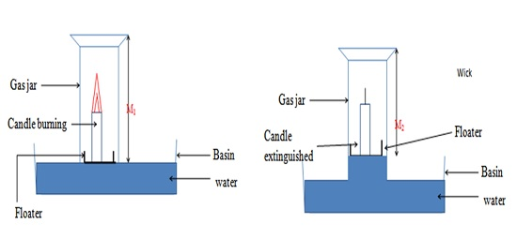

The first image shows the setup when experiment is setup, and the second setup shows the setup after the experiment  
The observations are made because;  
Candle burns in air. In a closed system (vessel), the candle continues to burn using the part of air that support burning/combustion. This is called the active part of air. The candle goes off/extinguished when all the active part of air is used up. The level of the water rises to occupy the space /volume occupied by the used active part of air  
  
**NOTE:** The experiment is better when very dilute sodium/potassium hydroxide is used instead of water. Dilute Potassium/ sodium hydroxide absorb Carbon (IV) oxide gas that comes out from burning/combustion of candle stick.  
  
From the setup above, the percentage composition of active part of air (oxygen) is calculated as follows;

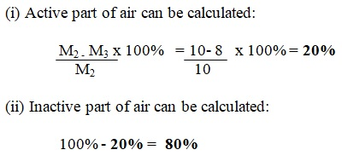

**There is a host of experiments that can be done to find the composition of the active part of air (oxygen) as follows;**

a) ***Using copper turnings as illustrated below***  
This is because copper reacts with oxygen to form Copper (II) Oxide

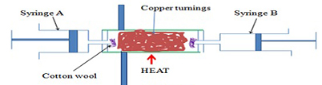  
**Copper + Oxygen Copper(II)Oxide**

**Important Notes**  
- The cotton wool in the experiment copper turnings from being blown into the syringe/out of the glass tube.  
- Air is passed through the glass tube repeatedly to ensure all the active part of air is used up.  
- Passing air through the glass tube slowly allows enough time of contact between the active part of and the heated copper turnings.  
- Colour changes from brown to black due to the reaction of brown copper metal with oxygen to form copper (II) oxide.  
- The reaction reduces the amount/volume of oxygen in syringe “B” leaving the inactive part of air, because copper only react with oxygen when heated.  
- The percentage of active part of air is theoretically higher because not all the active part of air reacted with copper.  
- If the copper turnings are replaced with magnesium shavings the % of active part of air obtained is extraordinary very high because magnesium is more reactive than copper, and the reaction is highly exothermic. Hence it generates enough heat for magnesium to react with both oxygen and nitrogen in the air.  
  
**Magnesium + Oxygen Magnesium (II) Oxide  
Magnesium + Nitrogen Magnesium (II) Nitride**

b) ***Using alkaline pyrogallol***  
In this test, the colour of pyrogallol/1, 2, 3-trihydroxobenzene change to brown.  
This is because oxygen gas is absorbed by alkaline pyrogallol/1,2,3-trihydroxobenzene.

c) ***Testing the presence of carbon (IV) oxide in air using lime water***  
Set up the experiment as shown below and pass tap water slowly into the empty flask.

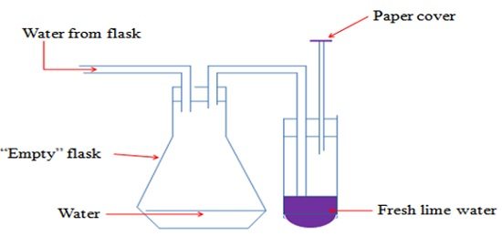

**Important Notes**  
- The paper cover ensures that no air enters into the lime water.  
- When water enters the flask, it forces the air from the flask into the lime water.  
- A white precipitate is formed. The white precipitate dissolves on prolonged bubbling of air.  
- Lime water is Calcium hydroxide / Ca(OH)2  
- The white precipitate formed is Calcium carbonate/ CaCO3  
*Calcium hydroxide + carbon (IV) oxide Calcium carbonate + water  
Ca (OH)2(aq) + CO2 (g) CaCO3(s) + H2O (l)*  
  
- When the white precipitate dissolves, the solution formed is Calcium hydrogen carbonate/ CaHCO3  
*Calcium carbonate + water + carbon (IV) oxide Calcium hydrogen carbonate  
CaCO3(s) + H2O (l) + CO2 (g) CaHCO3 (aq)*  
- Carbon (IV) oxide forms a white precipitate with lime water that dissolves in excess of the gas.

**Oxygen**

About 50% of the earth’s crust consist of Oxygen combined with other elements e.g. oxides of metals.  
About 70% of the earth is water made up of Hydrogen and Oxygen.  
About 20% by volume of the atmospheric gases is Oxygen that form the active part of air.

**Laboratory Preparation of Oxygen**

***(i) Using Hydrogen Peroxide***  
- Half fill a trough/basin with tap water. Place a bee hive shelf/stand into the water.  
- Completely fill the gas jar with water and invert in onto the bee hive shelf/stand.  
- Clamp a round bottomed flask and set up the apparatus as below.

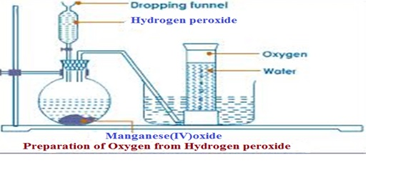

IMPORTANT NOTES:  
1. Rapid effervescence/bubbling/fizzing occurs when the hydrogen peroxide is added into the flask  
2. The gas produced is colourless and odourless  
3. The method of gas collection can be referred to as; over water, or upward delivery, or downward displacement of water.  
4. The gas can be collected through the method stated above because its only slightly soluble in water.  
5. Manganese (IV) oxide is used as a catalyst in the reaction. A **catalyst** is a substance that speeds up the rate of a chemical reaction but remain chemically unchanged at the end of the reaction  
6. Hydrogen peroxide decomposes slowly to form water and Oxygen gas.  
7. A little Manganese (IV) oxide speeds up the rate of decomposition by reducing the time taken for a given volume of Oxygen to be produced.  
8. The equation for the reaction is as follows;  
***Hydrogen peroxide Water + Oxygen  
2H2O2 (aq) 2H2O (l) + O2 (g)***  
9. Lowering a glowing splint slowly into a gas jar containing Oxygen gas relights/rekindles the splint. This is because Oxygen **relights/rekindles** a glowing splint; which is a confirmatory test for the presence of oxygen gas.  
  
***(i) Using Sodium Peroxide***  
- Half fill a trough/basin with tap water and add four drops of phenolphthalein indicator.  
- Place a bee hive shelf/stand into the water.  
- Completely fill a gas jar with water and invert in onto the bee hive shelf/stand.  
- Clamp a round bottomed flask and set up the apparatus as below.

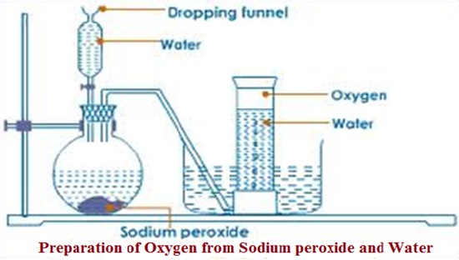

IMPORTANT NOTES:  
1. Rapid effervescence/bubbling/fizzing is observed when water is added into the flask containing sodium peroxide.  
2. A colourless and odourless gas is produced.  
3. The gas is collected using the 'over water' method because oxygen is only slightly soluble in water.  
4. The gas relights/rekindles a glowing splint.  
5. The reaction that occurs is represented by the equation below;  
***Sodium peroxide + Water Sodium hydroxide + Oxygen  
2Na2O2 (aq) + 2H2O (l) 4NaOH (aq) + O2 (g)***

**NB:** Oxygen can also be prepared using potassium chlorate (V) / 2KClO3

**Uses of Oxygen**

**a)** Oxygen is put in cylinders for use where natural supply is not sufficiently enough. It could include in places and activities like like mountain climbing, deep sea diving, saving life in hospitals.  
**b)** A mixture of oxygen and some other gases produces a flame that is very hot.  
- Oxy-acetylene/ethyne flame is produced when Ethyne/acetylene gas is burnt in pure oxygen. The flame has a temperature of about 3000oC.It is used for welding /cutting metals.  
- Oxy-hydrogen flame is produced when Hydrogen is burn in pure oxygen. The flame has a temperature of about 2000oC. It is used also for welding /cutting metals.  
**c)** Oxy-hydrogen mixture is used as rocket fuel.